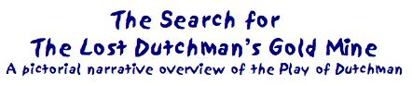
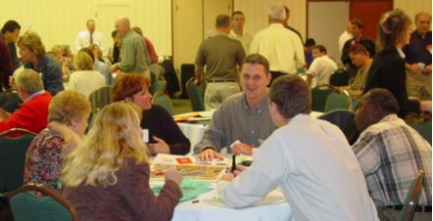

Looking for a way to energize your employees and put fire behind new initiatives in performance improvement?

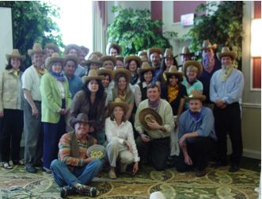

First, gather them together for a challenge to Mine Gold.

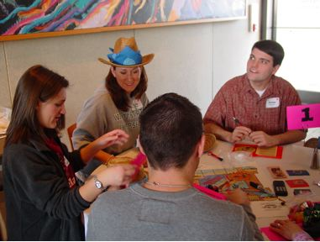
Separate them into teams of 5 or 6 people.

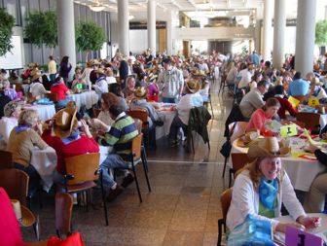
And play with LOTS of teams if you have them…

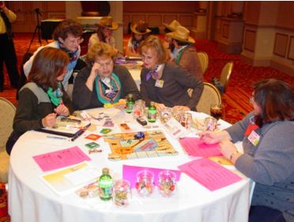
or have just a few. But let them make decisions and plans.


And, remember, it’s only a GAME!
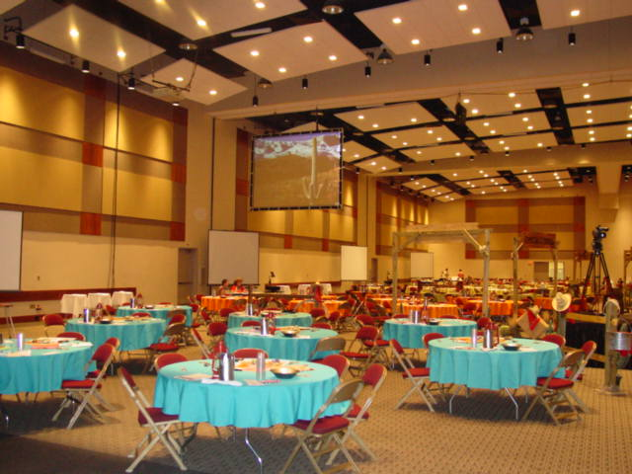

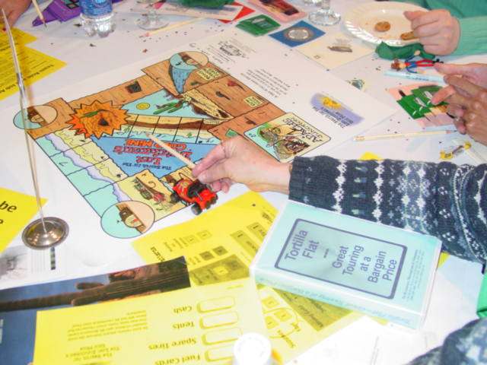
They’ll enter the room set with round tables. On each tabletop is a colorful poster map, a set of instructional materials and resources (Rules, Roles and more), a Grub Stake of resource cards representing needed supplies and other assorted trinkets and toys.

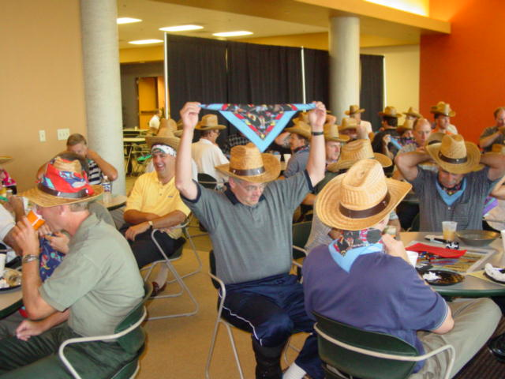

And they will need to get prepared and ready to play.
Cowboy hats and/or colored bandannas are a fun way to set the stage and embellish the theme.

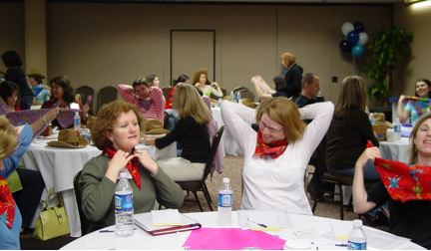
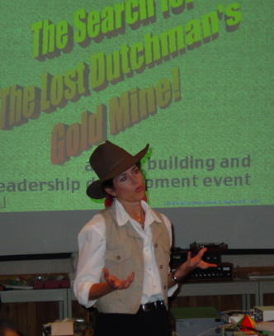

After everyone settles in, The Expedition Leader introduces him/herself and shares the interesting story and history of Jacob Waltz and his Lost Dutchman’s Mine.

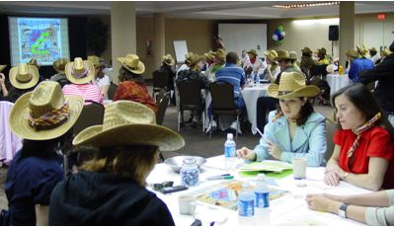
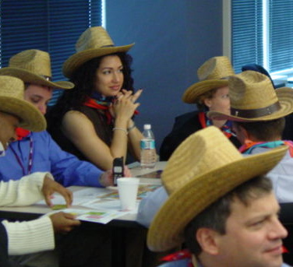

Then, it’s time to sit back and share the goals and learn all the rules and objectives of the exercise. Next, team members decide what particular assigned role they will assume.

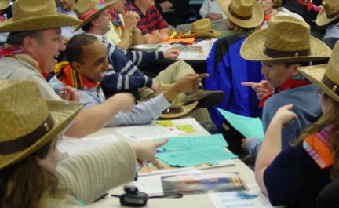
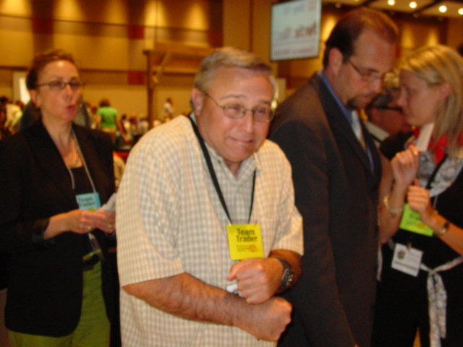

One of the most visible roles is Team Trader and once the journey begins, this teammate will be very busy going to and from the Provisioner’s Table each of the twenty 2-minute days to give up Supplies and Fuel to the Provisioners (who are often
your company’s managers and support people in large events).

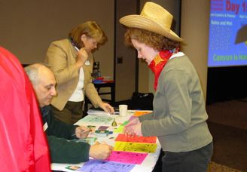
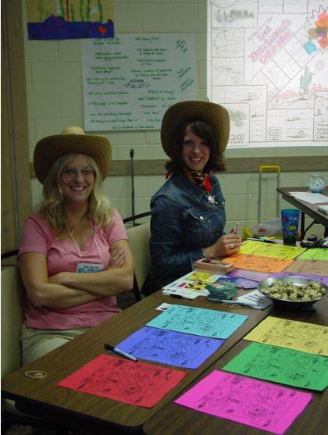

Provisioners easily track who does what, the decisions teams make and the Gold that they Mine, information used to debrief the collaboration and cooperation and to assist a discussion of possibilities for change.
Once the introduction of the exercise is completed, Teams have 15 minutes to plan their journey to and from The Lost Dutchman’s Mine. Among other things, they’ll first need to decide which of 3 paths they’ll take, what resources they really need and how much risk they want to take.

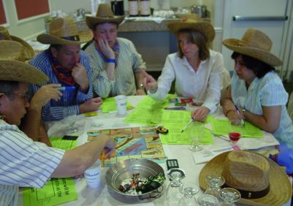

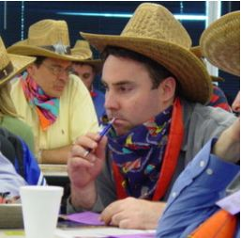
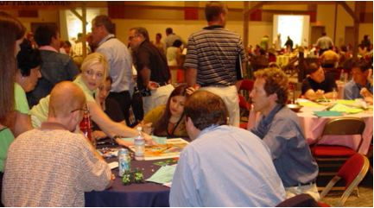

A final call to tell everyone they have only a minute left before Day 1 of the journey begins ALWAYS generates some energy. Then the chaos, confusion and FUN of Day 1 happens!

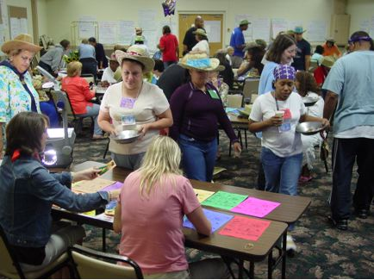

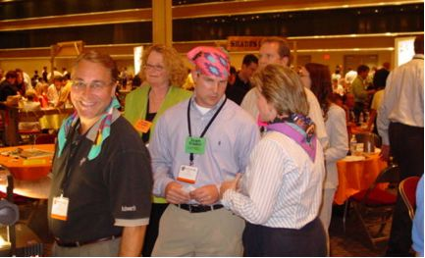

It gets busy at the Trading Table! But Traders can also share information about what their teams are doing and share ideas for optimization of outcomes. They CAN, but WILL they?
And the Provisioners may put pressure on the teams to be timely, accurate and complete in their work.

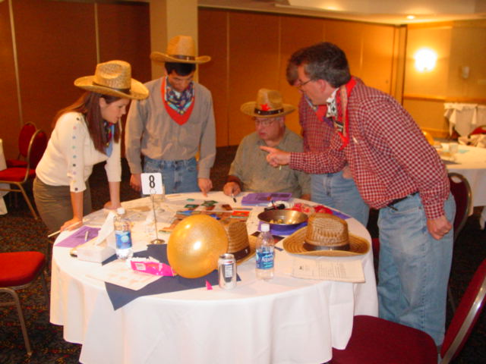
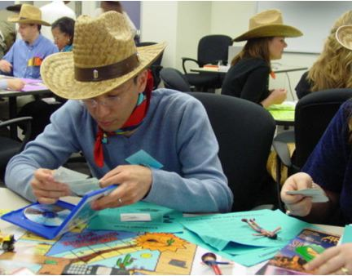

Teams have to plan ahead. They also need to decide if they want additional information that’s available from two separate “videos.” They are told that teams find this information to be valuable and helpful, but it will cost them one day of time for each or two days for both videos. Decisions, Decisions!

This team is staying behind in Apache Junction and delaying their start until Day 3 so they can review the “videos” (blue box above) in hopes of better planning their journey. Believe it: Planning and Information are very much helpful to the teams in their drive to Mine as Much Gold as We Can!

But the sense of competition and the natural competitiveness commonly caused by a “My Team, My Team, My Team” focus measurably sub-optimizes the group performance results.

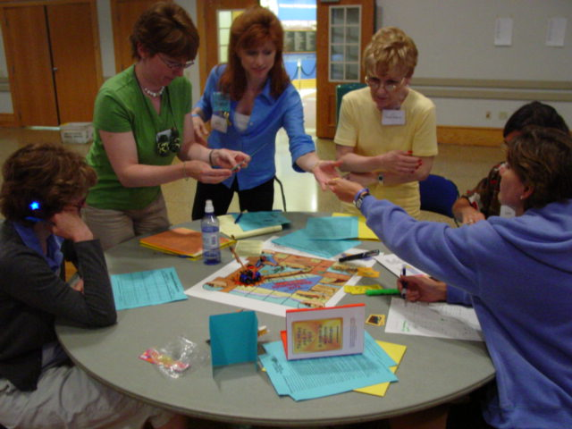

While Traders spend their days going back and forth to the Provisioner’s Table, other team members perform analysis and planning their roles within the team. They may also interact with the other teams for information and resources.

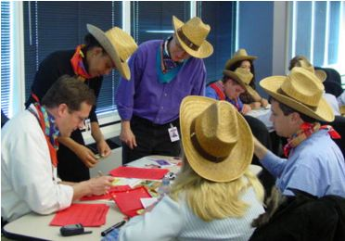

Some teams work their plan well together and use their information wisely. For them, it’s less stress and more success.
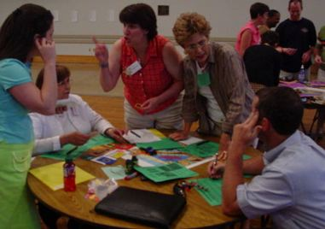

While other teams will feel a little harried or experience discord when their plans don’t come together well!



Remember, it’s only a GAME!
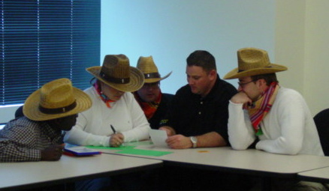

Interestingly, teams often react competitively in the journey and thus don’t fully collaborate with other teams. Often, they have information that they could share but choose not to…

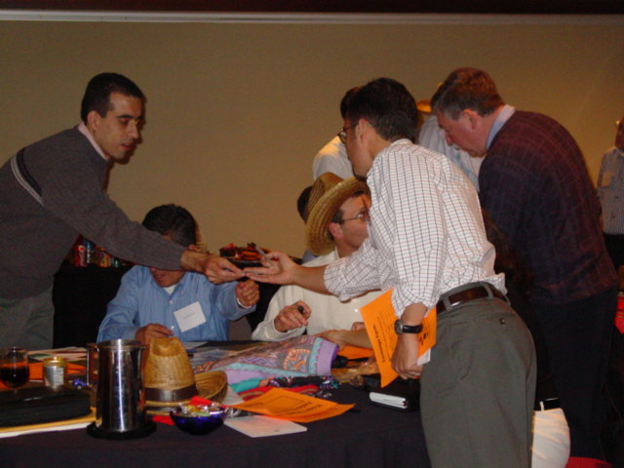

For instance, teams that stayed behind to watch the “videos” received resource cards to help them mine gold using fewer resources and discover a faster way to and from the Mine; valuable information they should be sharing with others.
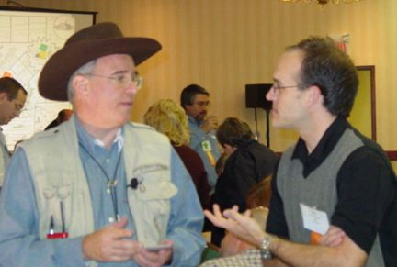

Team members can improve their results by asking the Expedition Leadership for advice, something they could do anytime throughout the play -- yet this valuable resource is seldom used! The expressed role of the Expedition Leader is, “to help teams be successful.” Teams don’t often ask for advice!

This is one of our common debriefing points. The leadership was there to help teams succeed and to offer much more than a clarification of the rules or to process team transactions. But people will often resist suggestions; so we don’t try to tell them what to do, letting them make their own decisions. After all, they are responsible for their individual and team results.

But if they ASK for help, we help! Heck, I carry extra Supply and Fuel Cards in my pocket just in case someone asks about how they might acquire just one more Fuel or Supply Card.

One $10 Fuel often generates $2500 in Gold!
The Goal is to Mine as Much Gold as We Can!

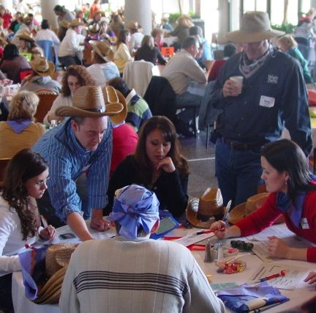

The 20 Days are fast-paced and challenging, just as in the workplace, which requires collaboration and planning.

That is the President of the Organization on the right with the coffee, looking on as a team plots and plans and executes. HE is looking for the teams to Mine as Much Gold as WE Can, of course. Later, he was up front debriefing that most relevant development question,

“What does Mining Gold mean to us as an organization?”
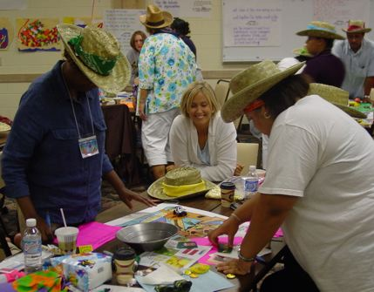

We challenge them to succeed.
And it is Fun as well as a great learning experience.

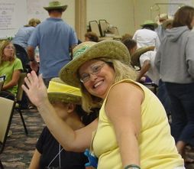

At the end of the 20-Day journey, players head out for a break before the invaluable debriefing begins.

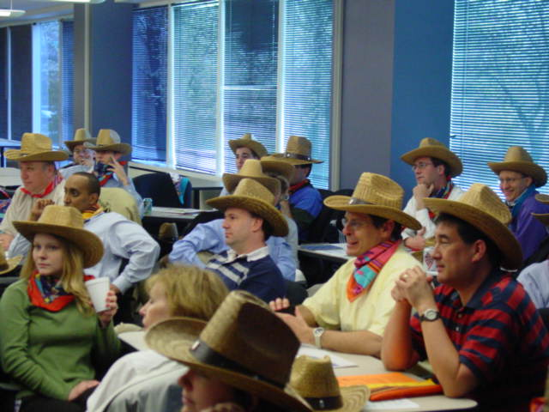

They’ll return to a debriefing session that elegantly links the play of game and participant behaviors to workplace issues. Here, things get more serious as we relate what they did to what they do with focused discussions and observable, measurable results.

Play represents Work quite well.

Behaviors in the game are generally congruent with what really happens in the workplace. We have 14 years of our personal experiences as well as comments by consultants and users worldwide that confirm this nicely.

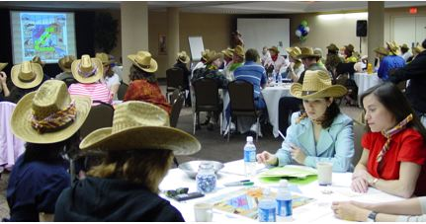

This debriefing process is extremely flexible and the more time devoted to it, the better the payoff for participants to understand the benefits of collaboration, teamwork, communications, planning, etc.

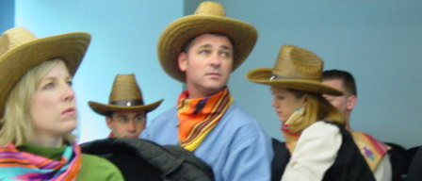

"This outstanding program creates instant awareness about our almost instinctual drive to compete against our own colleagues," says George Smart, Managing Partner of Strategic Development in Durham, North Carolina. “People are in such a hurry to ‘get on with’ a project they make competitive assumptions which cost them thousands of hours and millions of dollars.”

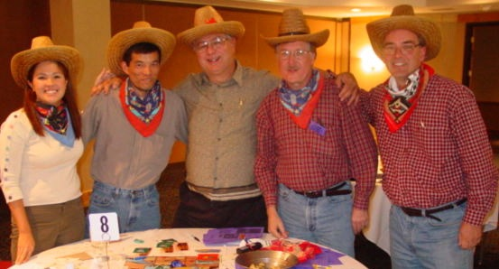

In the end, people will better understand how a successful and productive team works as well as how their own behavior contributes to this. They will have experienced memorable learning and have an opportunity to discuss what they can choose to do differently in the future. This works elegantly.

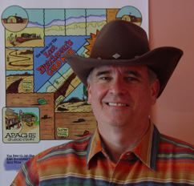

As the creator of Dutchman, I’m here to help you! Just call Scott at 864-292-8700 or scott@squarewheels.com

